**Republic of the Philippines**

**City of Taguig**

**Taguig City University**

Gen. Santos Avenue, Central Bicutan, Taguig City

**MANAGEMENT INFORMATION SYSTEM**

**ACCOMPLISHMENT REPORT**

**For the Month of October 2019**

|  |  |  |
| --- | --- | --- |
| **Date** | **Actual Accomplishment** | **Result** |
| October 1- 31, 2019  October 1 – 31, 2019  October 1 – 31, 2019 | * Encode the requirements of grade 12 students * Assist Students in their account in Information System. * Assist students of transferring files in Laboratory. * Assist Student in admission of monitoring. | **On-Going**  **Successfully completed**  **Successfully completed** |

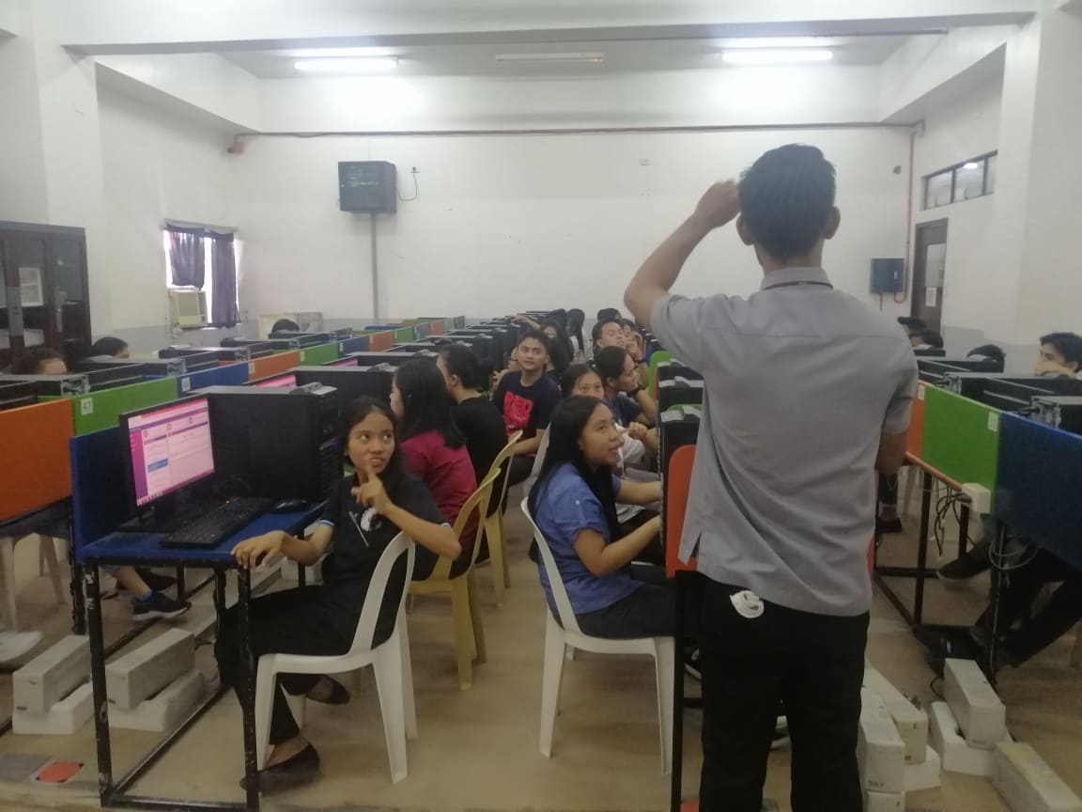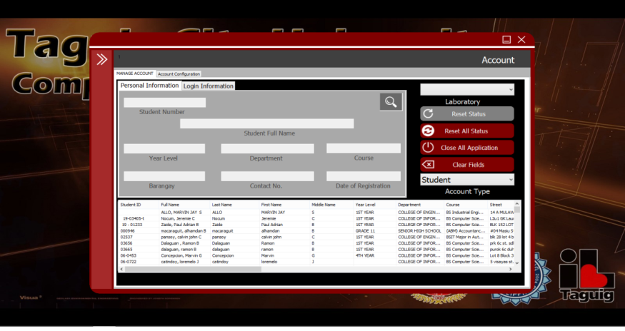

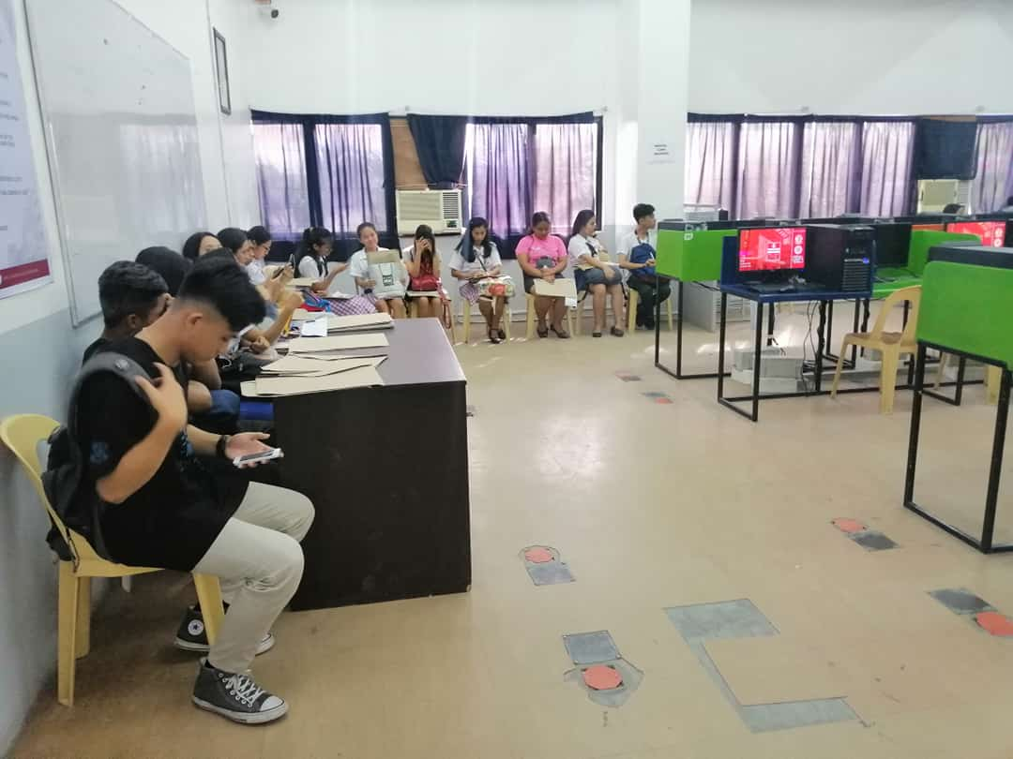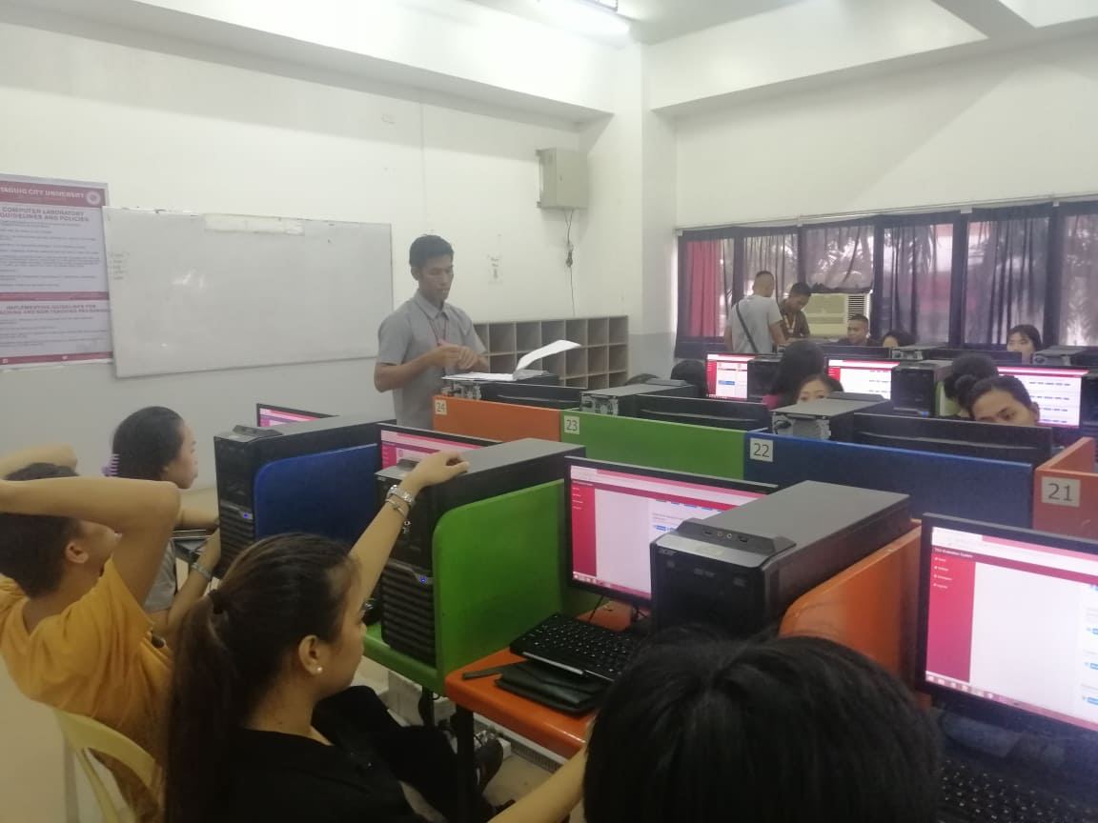

**Prepared By: Approved By:**

**Ivan A. Franco Dr. Reagan Ricafort**

**Technical Support, MIS Director, MIS**